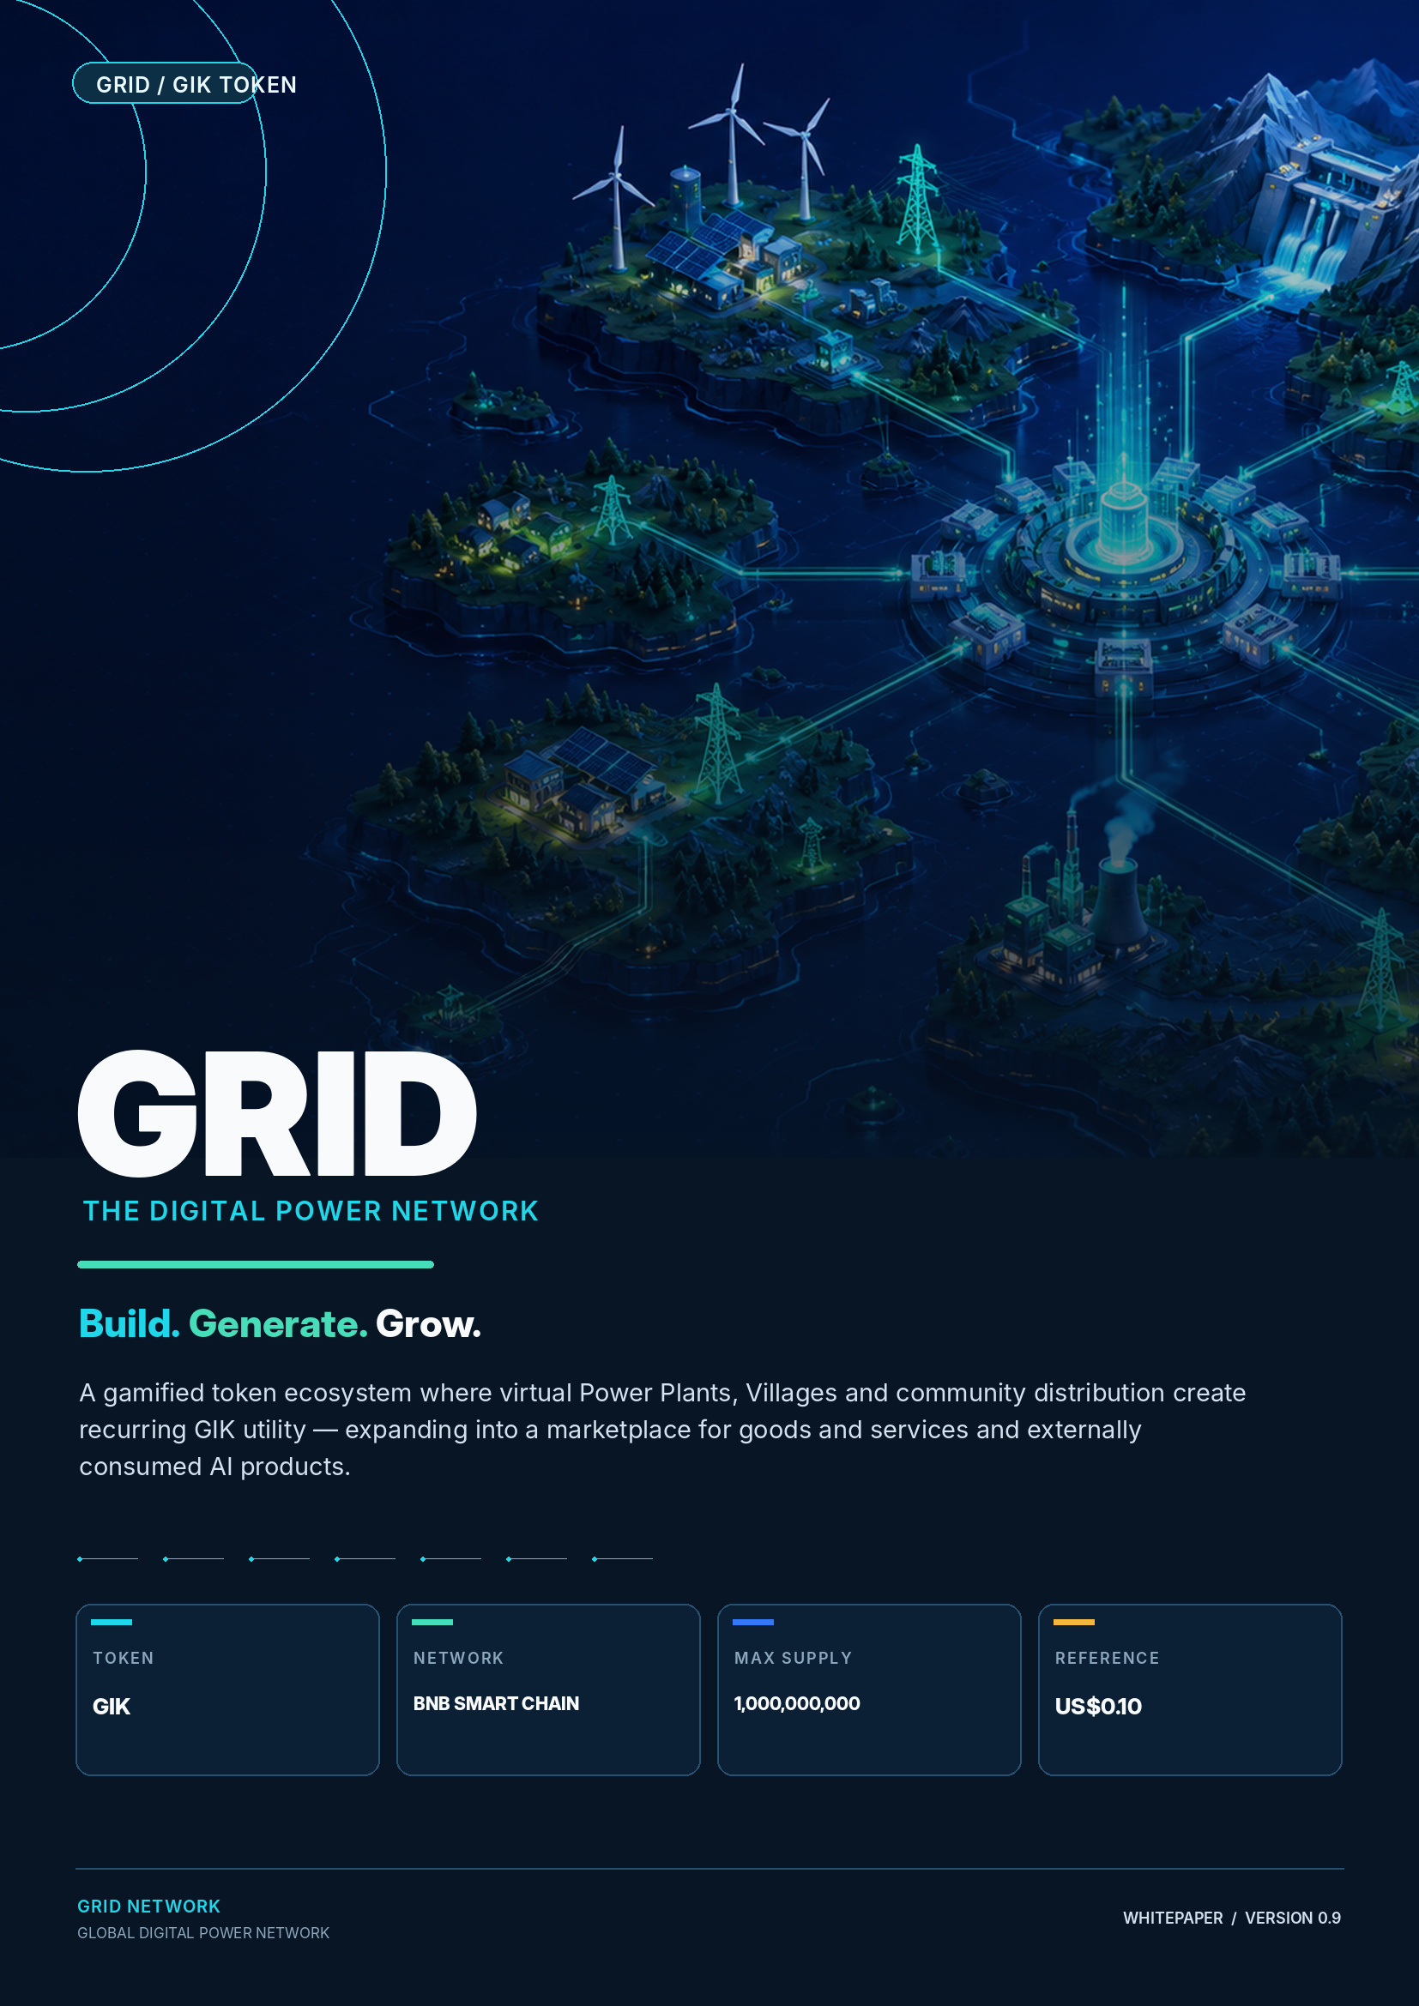

00 / EXECUTIVE OVERVIEW

Executive Overview
GRID combines a game-like participation layer, a fixed-supply token economy, automated member infrastructure and a staged path toward marketplace and AI utility.

GRID is a digital power network built around one simple idea: token utility becomes more understandable and engaging when users can see what they are building. The ecosystem connects a public information site, a logged-in game world and an operations console. Members use GIK to activate and expand virtual Power Plants, then move visually from My Power Plant to My Village and the wider World Grid.
The initial platform creates recurring GIK utility through Plant activation, upgrades, module expansion, automated reward settlement and permanent token burn. The long-term roadmap extends GIK into a marketplace for goods and services, AI SaaS, agents, API credits and future compute services intended for members and external customers.
1 BILLION GIK  Proposed fixed maximum supply on BNB Smart Chain. | 3 CORE PLANT TIERS  2,000 / 8,000 / 15,000 GIK, followed by 15K expansion modules.
UP TO 200% CAP  Maximum personal generation under the current programme design. | 7 VILLAGE LEVELS  Monthly progression, visual evolution and up to +7% Village Bonus.

The GRID thesis
Community participation builds the network. Marketplace and external AI products expand utility beyond it. A fixed supply, transparent token flow and built-in burn connect these layers into one economy.

Document scope
This whitepaper presents the intended GRID ecosystem, product architecture, token utility, reward framework, token allocation, release schedules, automated deposit and settlement architecture, marketplace and AI roadmap, member-balance model and operational controls. Quantitative programme parameters may be updated through published platform rules as the ecosystem develops.

00.1 / CONTENTS

Contents
A concise structure for project, product, token and market review.

SECTION | TOPIC
01 | The Market & GRID Thesis
02 | Ecosystem Architecture
03 | Product Experience
04 | Power Plant System
05 | Upgrades & Expansion
06 | Village Network
07 | Reward Architecture
08 | GIK Demand Engine
09 | Supply & Burn
10 | Tokenomics
11 | Treasury & Transparency
12 | Marketplace & External Utility
13 | Technology & Security
14 | Go-to-Market & Exchange Strategy
15 | Roadmap
16 | Organization & Governance
A | Platform & Operational Parameters
A.1 | Member Operations
A.2 | Genealogy & Custody Controls
R | References & Important Notice

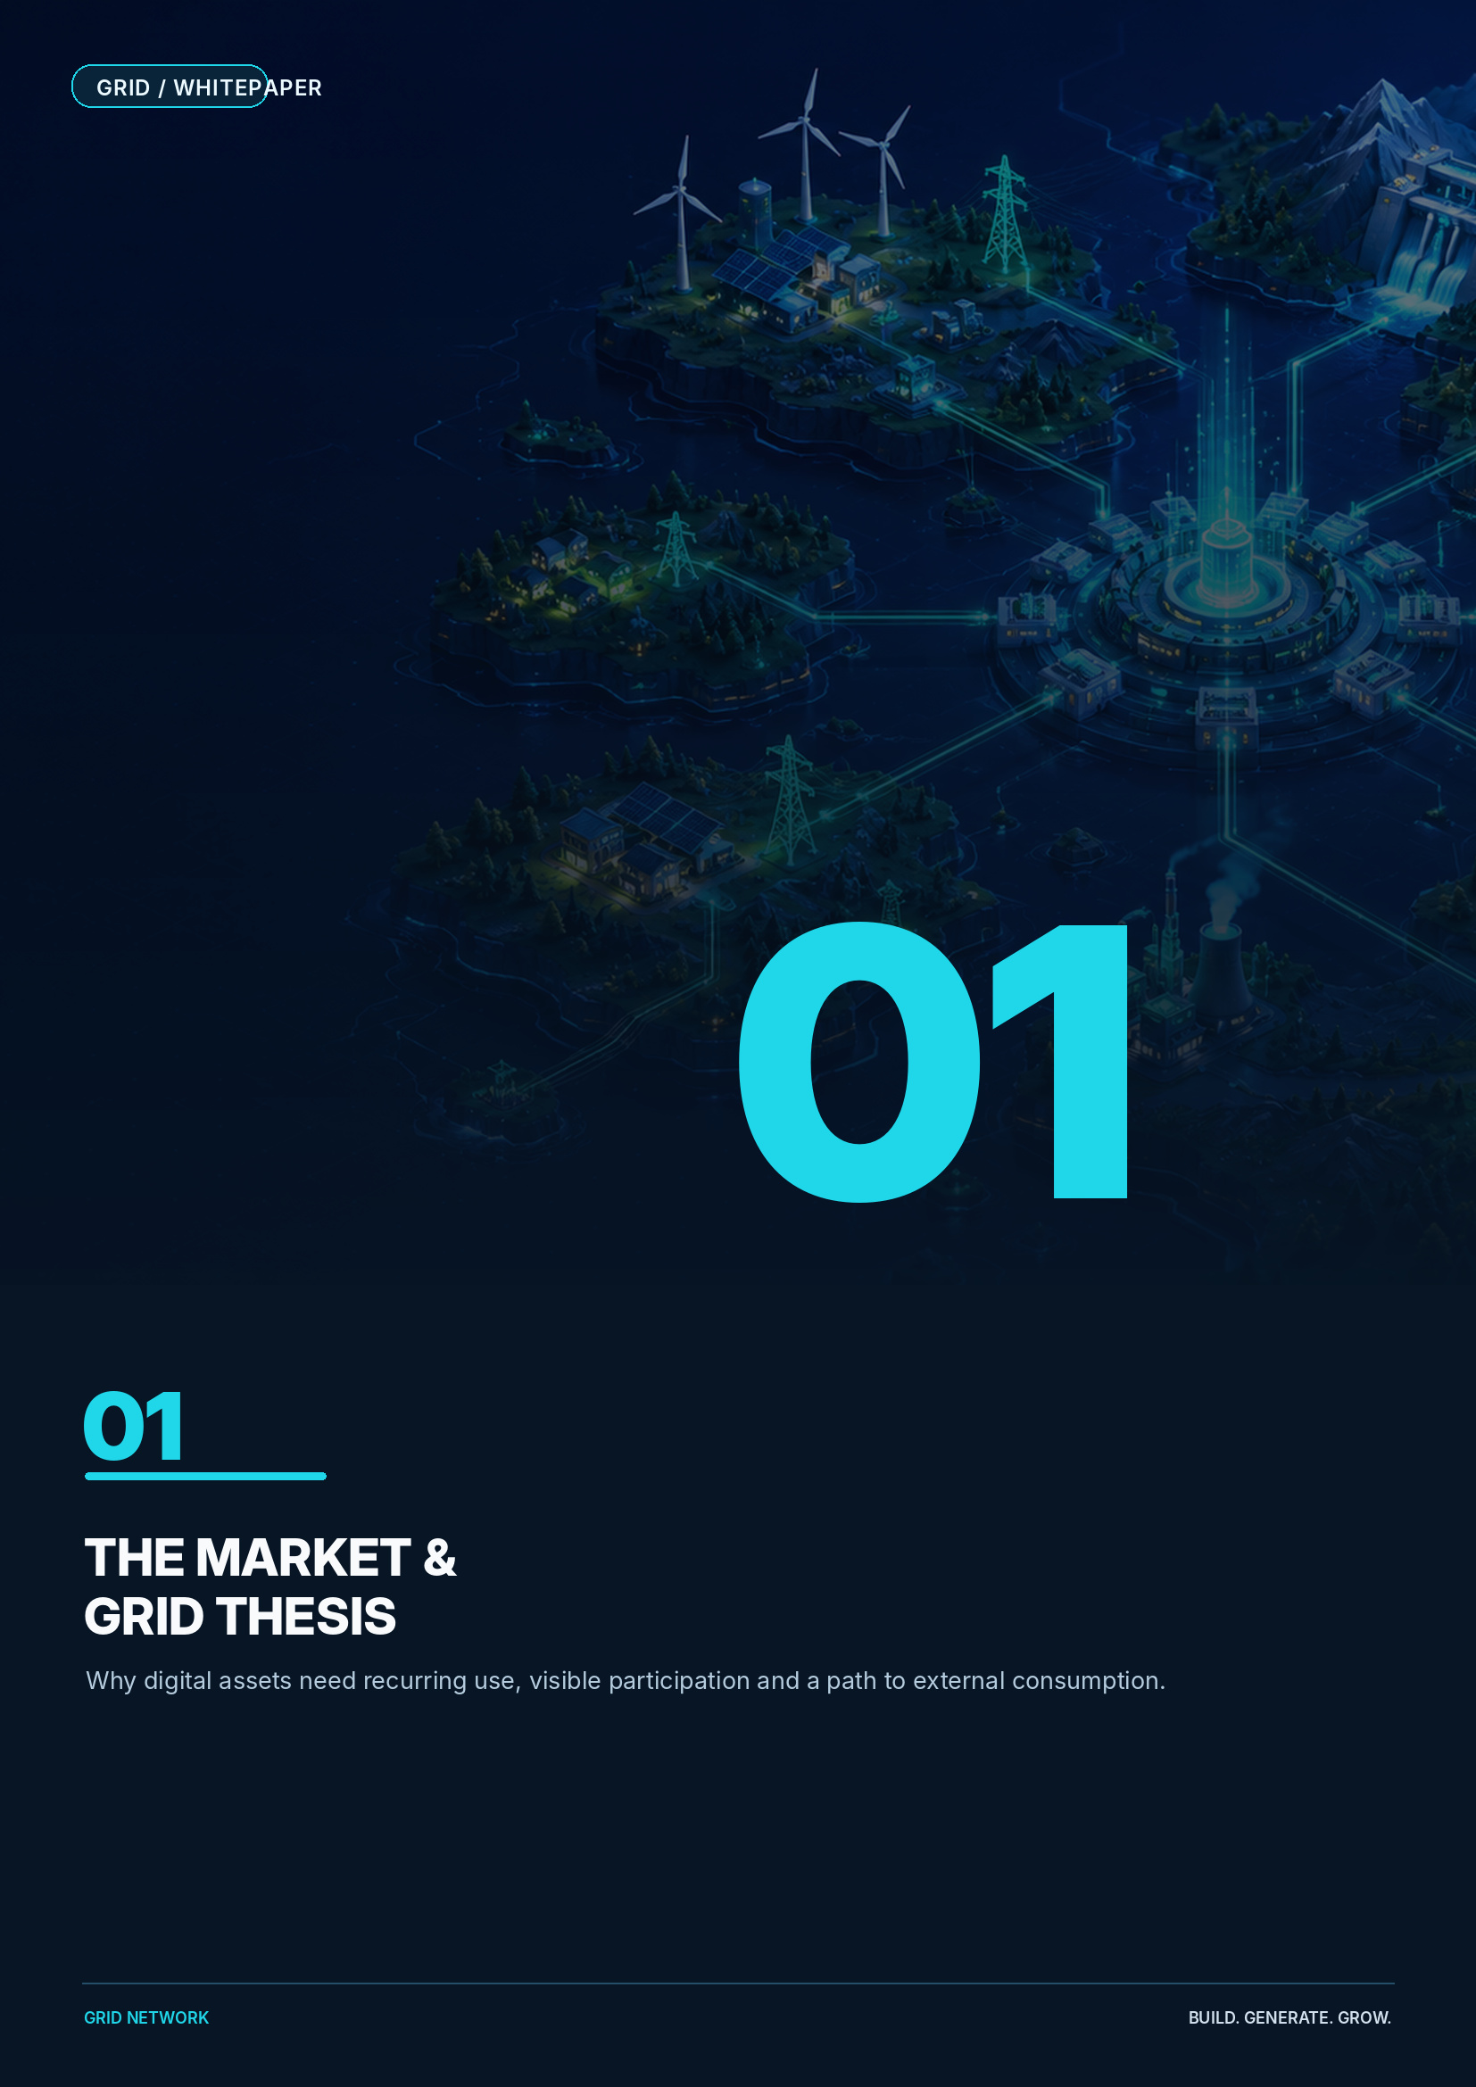
01 / THE MARKET PROBLEM

The Market Problem
Many digital assets can be traded, but too few give users a repeated reason to acquire, use and remain engaged with the token.

THE HOLD-AND-WAIT PROBLEM  Many tokens depend mainly on attention, narrative and finding the next buyer. When attention declines, repeated utility is weak. | THE ENGAGEMENT PROBLEM  Conventional financial dashboards create little sense of ownership, progression or community identity.
THE CLOSED-LOOP PROBLEM  Rewards alone do not create external consumption. A durable ecosystem needs users who consume real products and services. | THE COMPLEXITY PROBLEM  AI infrastructure and Web3 are difficult for non-technical users to understand. Participation needs a simpler visual language.

AI as the long-term opportunity
AI adoption is increasing demand for digital infrastructure, computing and electricity. The International Energy Agency projects that global data-centre electricity consumption could more than double to approximately 945 TWh by 2030, with AI the most important driver of growth.[1] The OECD likewise identifies concentration, capital intensity and barriers to entry across the AI infrastructure supply chain.[2]
GRID reframes the opportunity
GRID uses the familiar language of power generation to make participation simple today, while building toward actual AI-service consumption tomorrow.

01.1 / THE GRID THESIS

The GRID Thesis
Transform token ownership from passive holding into visible participation, progression and service utility.

DESIGN PRINCIPLE | GRID APPROACH | ECONOMIC EFFECT
Utility before speculation | GIK is used to activate, upgrade and expand Power Plants and, over time, to access AI services. | Creates repeated reasons to use GIK.
Visible progression | Power Plants and Villages evolve visually as capacity and generation increase. | Improves comprehension, retention and identity.
Upfront demand, gradual release | Plant activation requires GIK upfront while generation is distributed over time. | Concentrates acquisition demand at entry.
Bounded supply | GIK is designed with a fixed maximum supply and no routine inflationary minting. | Creates a clearly measurable supply base.
Built-in burn | Every reward withdrawal applies Transmission Loss, and the deducted GIK is irreversibly burned on-chain. | Permanently reduces total supply through platform usage.
External consumption | GIK is designed for purchases inside the future GRID Marketplace and for AI services consumed by members and external customers. | Expands the addressable economy beyond community participation.

BUILD → GENERATE → GROW → USE
GRID begins as a digital participation network and expands into marketplace, service and AI utility.

02 / ECOSYSTEM ARCHITECTURE

Ecosystem Architecture
GRID combines three coordinated product spaces and one token economy under a single brand.

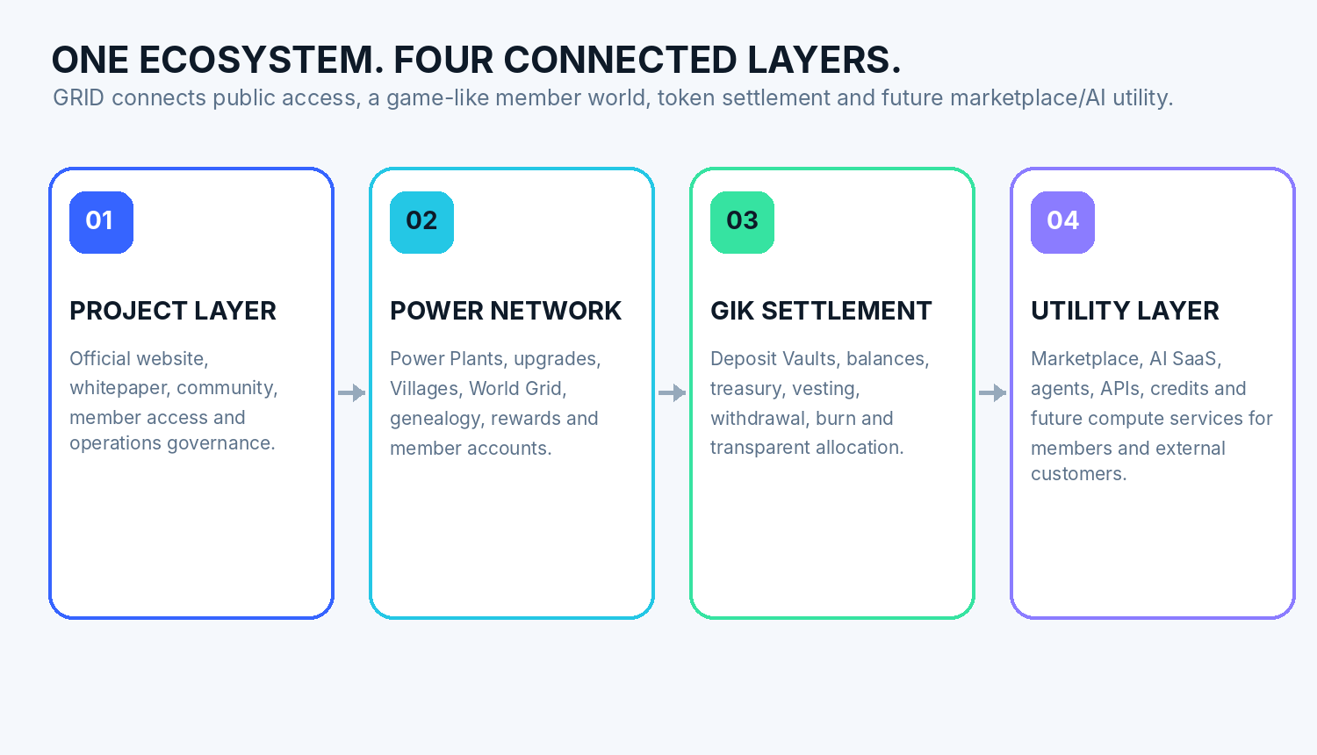
- The platform is organised as a public website, a logged-in member world and a separate operations console, while remaining one connected GRID experience.
- English is the default language; Korean is automatically displayed for Korean-language devices, with manual language switching available.
- The member experience is designed as a village-building game rather than a conventional compensation dashboard: My Power Plant → My Village → World Grid.
- Each member receives a unique on-chain Personal Deposit Address backed by a member-specific BSC Deposit Vault; valid GIK deposits are detected automatically and trigger the relevant Plant action.
- Generation, network rewards, withdrawals, Transmission Loss burn, vesting/unlock and Treasury sweeps are automated by default. Staff focus on monitoring, security and exceptions, while a persistent Action Center keeps unresolved member issues visible.

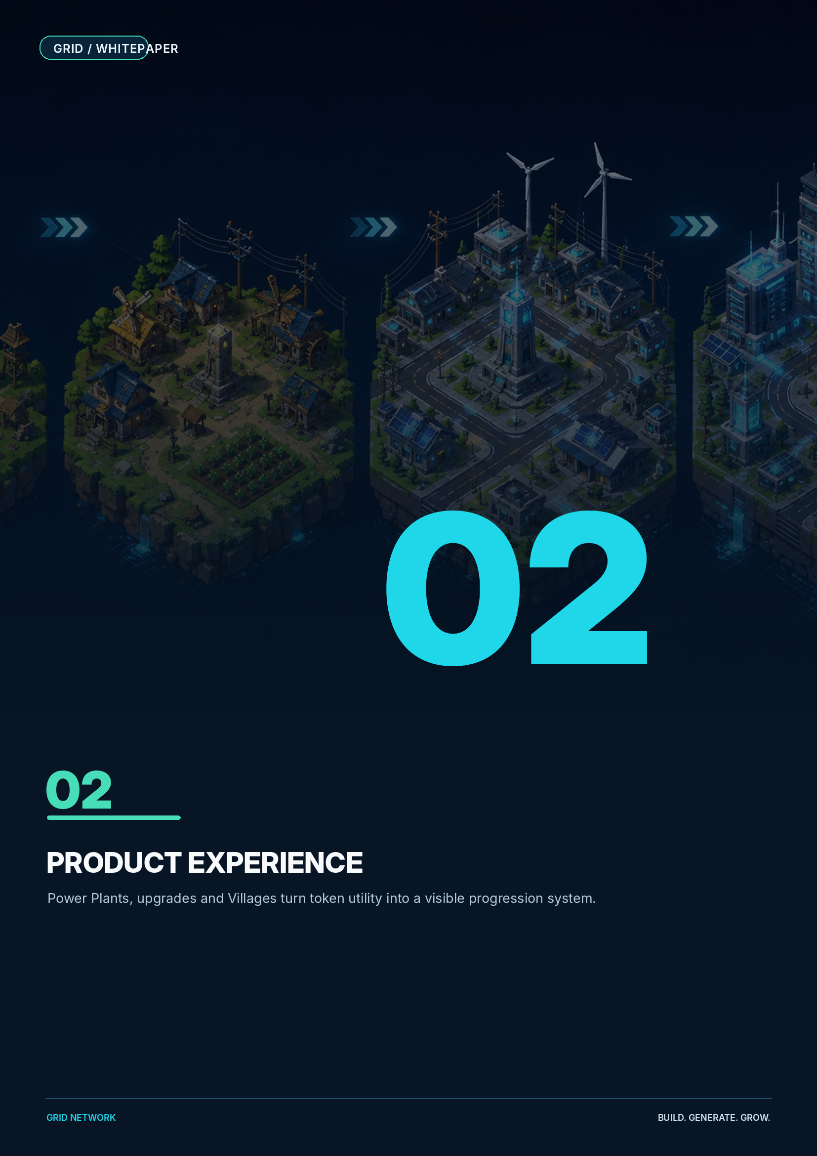
03 / BUILD YOUR POWER PLANT

Build Your Power Plant
Every GRID journey begins with a Power Plant. Larger Plants generate more GIK and unlock deeper network participation from the next GRID settlement day.

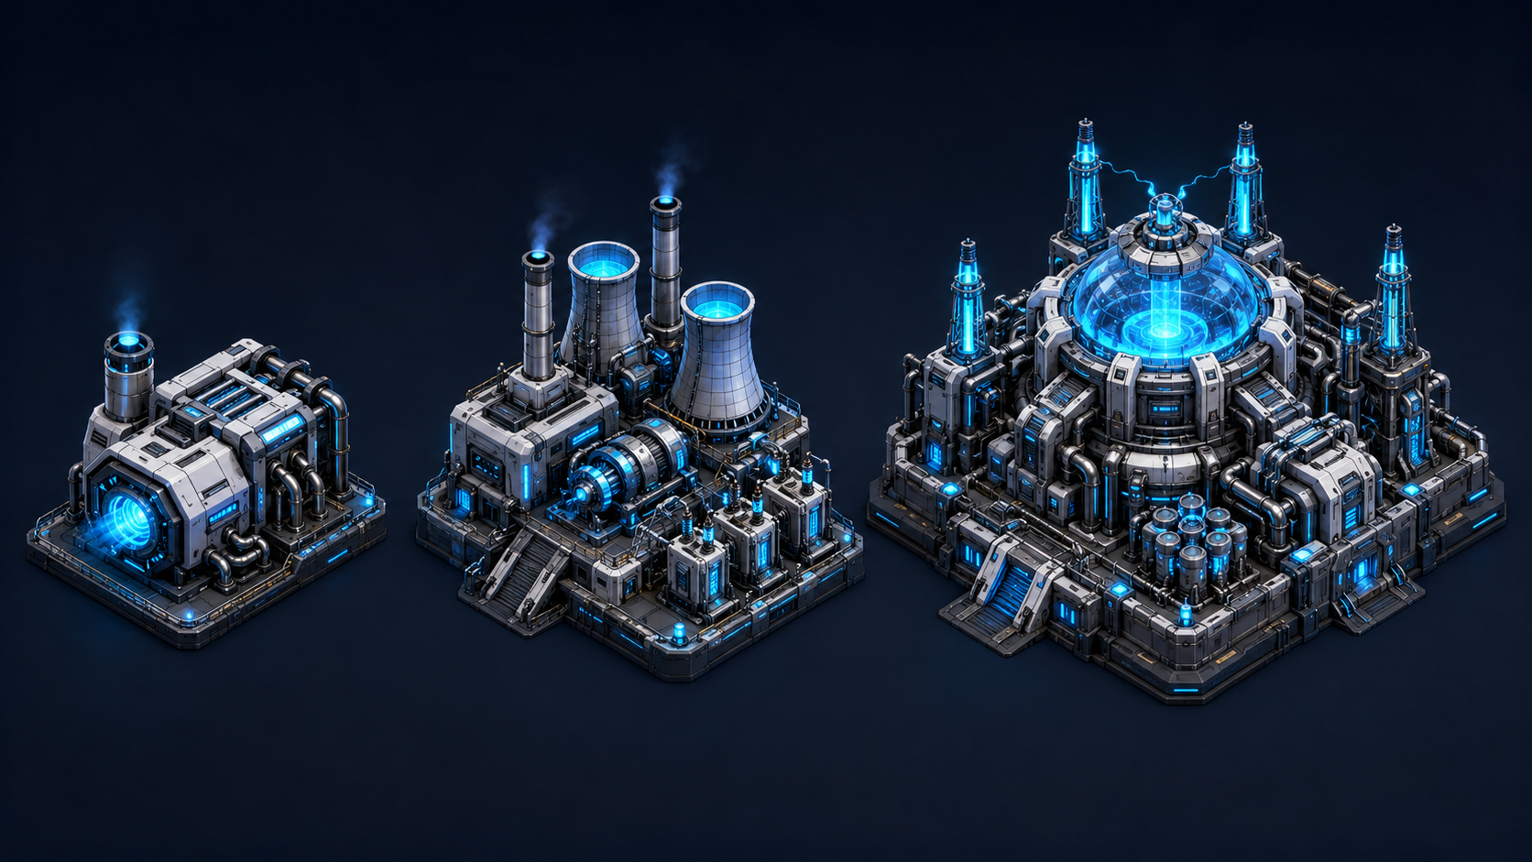
Illustrative visual direction: Small Generator → Medium Power Plant → Core Power Plant.
PLANT | CAPACITY | STARTUP GENERATION | STABLE GENERATION | DAILY OUTPUT AFTER WHOLE-GIK FLOOR
Small Generator | 2,000 GIK | Days 1–15: 0.15%  Days 16–30: 0.125% | 0.10% / day | 3 → 2 → 2 GIK
Medium Power Plant | 8,000 GIK | Days 1–30: 0.80%  Days 31–60: 0.60% | 0.50% / day | 64 → 48 → 40 GIK
Core Power Plant | 15,000 GIK | Days 1–30: 1.75%  Days 31–60: 1.35% | 1.00% / day | 262 → 202 → 150 GIK

Generation timing and cap
A Plant activated today generates nothing on the activation day and becomes eligible at the next 01:00 GST settlement. Each recognised Plant or module may generate up to 200% of active capacity. Reward calculations are floored to whole GIK.

04 / UPGRADE AND EXPAND

Upgrade and Expand
Members can start small, move through the supported tiers and continue growth through independent 15K modules.

ACTION | GIK REQUIRED | EFFECT FROM NEXT 01:00 GST SETTLEMENT
2K → 8K Upgrade | 6,000 additional GIK | The whole Plant becomes an 8K Plant and begins the 8K Startup schedule.
2K → 15K Upgrade | 13,000 additional GIK | The whole Plant becomes a 15K Core Plant and begins the Core Startup schedule.
8K → 15K Upgrade | 7,000 additional GIK | The whole Plant becomes a 15K Core Plant and begins the Core Startup schedule.
15K+ Expansion | 15,000 GIK per module | Each new module starts its own Core Startup schedule; existing modules continue unchanged.

FLEXIBLE ENTRY  Participants do not need to begin at the highest tier. Upgrade uses only the GIK difference. | NO FULL RESET AFTER 15K  Expansion modules are independent, preserving the timeline of existing modules.
VISIBLE EVOLUTION  As capacity grows, the Plant complex expands and its visual tier evolves. | REACTIVATION  After a Plant reaches its maximum cap, a new active cycle begins from the newly committed capacity.

05 / GROW TOGETHER THROUGH VILLAGES

Grow Together Through Villages
Every Plant belongs to a Village defined by the Company Root’s direct-line genealogy. Village performance becomes visible, social and rewarding.


Illustrative Village progression from a small settlement to a future GRID capital.
VILLAGE LEVEL | PRIOR MONTH QUALIFYING GENERATION | NEXT MONTH BONUS
Lv.1 | 0–99,999 GIK | 0%
Lv.2 | 100,000–299,999 GIK | +0.5%
Lv.3 | 300,000–999,999 GIK | +1%
Lv.4 | 1,000,000–2,999,999 GIK | +2%
Lv.5 | 3,000,000–9,999,999 GIK | +3%
Lv.6 | 10,000,000–29,999,999 GIK | +5%
Lv.7 | 30,000,000 GIK+ | +7%

- Each direct line beneath the Company Root defines one Village; the entire descendant subtree remains in that Village regardless of depth.
- Village level is determined by the previous GST business month’s qualifying personal Plant generation and changes the environment, central monument and visual identity of the community.
- Village Bonus is calculated on members’ qualifying personal generation during the following month.
- Centers are separate sales/operations units inside a Village; creating a Center does not create or split a Village. Secondary rewards do not count again toward Village level.

06 / REWARD ARCHITECTURE

Reward Architecture
GRID combines personal generation, fixed genealogy, bottom-up rank differentials, Center leadership and Village performance.

PERSONAL GENERATION  Daily GIK generated by the member’s active Power Plant or expansion modules. | REFERRAL GENERATION  0.5% of qualifying downline personal generation across 5, 10 or 20 generations depending on the member’s active Plant tier.
RANK DIFFERENTIAL  R1–R7 rewards are calculated bottom-up. The lowest eligible same-rank member occupies that rate position; upstream leaders receive only the remaining differential, up to 10% in total. | VILLAGE & CENTER  Village Bonus reflects monthly collective generation. Center Fee follows a separate 2.0% → 1.0% → 0.5% floor hierarchy, capped at 2.0% in aggregate for a qualifying sale.

No compression
Inactive or unqualified positions remain in their original genealogy position. Unpaid rewards are not shifted upward and are not issued.

Activity alignment
Network rewards require an active personal Power Plant. When a Plant completes its generation cycle, personal and network eligibility pauses until the member establishes a new active Plant. Genealogy position and historical Rank remain intact, and unqualified amounts remain unissued rather than moving upward.
Center Fees settle twice monthly at 01:00 GST: on the 16th and on the first day of the following month. Programme parameters may be updated through published platform rules.

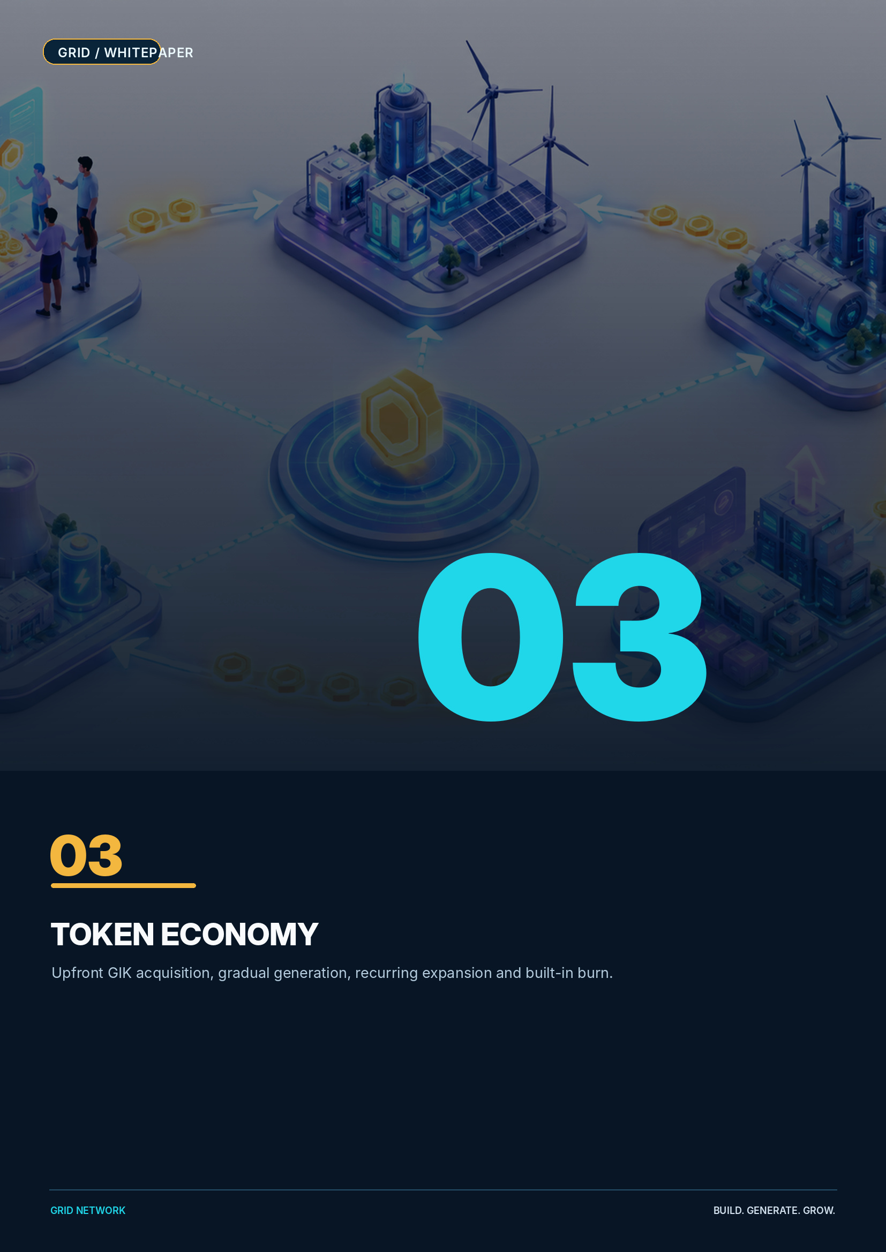
07 / WHY GIK HAS RECURRING DEMAND

Why GIK Has Recurring Demand
A new Power Plant cannot exist without GIK. Activation, upgrade, expansion, reactivation and future marketplace spending create repeated utility demand.

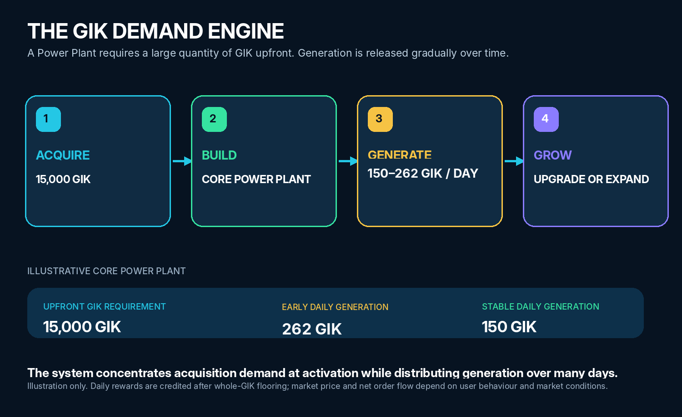
GIK DEMAND DRIVER | HOW IT WORKS
New Plant activation | Participants acquire GIK to enter the GRID ecosystem and activate a Plant.
Tier upgrades | A member acquires the difference required to move from 2K to 8K or 15K.
15K expansion modules | Each additional module requires another 15,000 GIK.
Reactivation | A completed Plant begins a new active cycle from newly committed GIK.
Village competition | Collective progression encourages members to maintain and expand active generation.
GRID Marketplace | The planned GRID Mall allows approved sellers to offer goods and services that members can purchase with GIK at community-oriented pricing.
External service utility | Future AI tools, agents, APIs and compute products are designed to add demand from customers outside the network programme.

Structural demand advantage
Plant construction requires a large GIK quantity upfront, while the related generation is distributed gradually. This creates a clear difference between the timing of token acquisition and token release.

08 / TOKEN FLOW AND BURN

Token Flow and Burn
GRID separates deposited Available GIK from earned Reward Balance and applies a permanent supply-reduction event to reward withdrawals.

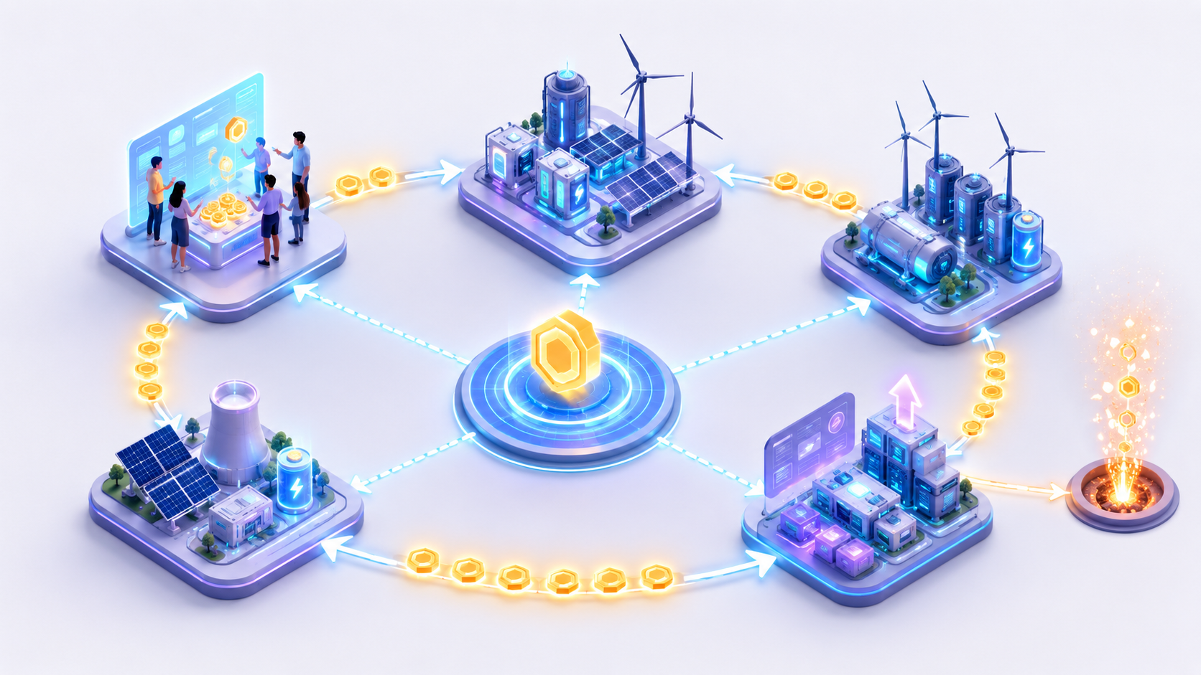
Conceptual token flow: acquire → build → generate → withdraw → burn → hold, trade or rebuild.
CAPACITY BASIS | TRANSMISSION LOSS
2,000–30,000 GIK | 5%
45,000–75,000 GIK | 10%
90,000–135,000 GIK | 20%
150,000 GIK and above | 30%

- Available GIK records member-deposited GIK that has not yet been used, including excess or late deposits. It can fund a Plant action without fee or be withdrawn from 100 GIK with a 1% Withdrawal Fee paid to the company Treasury.
- Reward Balance records Generation and network rewards. It cannot be used directly for a new Plant; the minimum withdrawal is 500 GIK, with no member daily withdrawal cap and a 24-hour lock after a withdrawal-address change.
- Reward withdrawals apply the 5% / 10% / 20% / 30% Transmission Loss schedule. If current active capacity is zero, the last active recognised Plant capacity determines the rate. The deducted GIK is permanently burned on-chain.
- A Deposit Intent remains valid for seven days. Underfunded deposits may be aggregated during that period; post-expiry deposits and any residual amount are credited to Available GIK.
- GIK committed to Plant construction enters the ecosystem treasury and is not automatically burned. Material unresolved issues remain visible in the member Action Center until resolved or acknowledged.
Two balance paths, one transparent system
Deposited GIK and earned rewards remain distinct in the internal ledger. Available-balance fees are company revenue; Transmission Loss is not revenue and is permanently burned.

09 / GIK TOKENOMICS

GIK Tokenomics
A fixed maximum supply and activity-linked emission support transparent allocation, measurable circulation and long-term ecosystem planning.

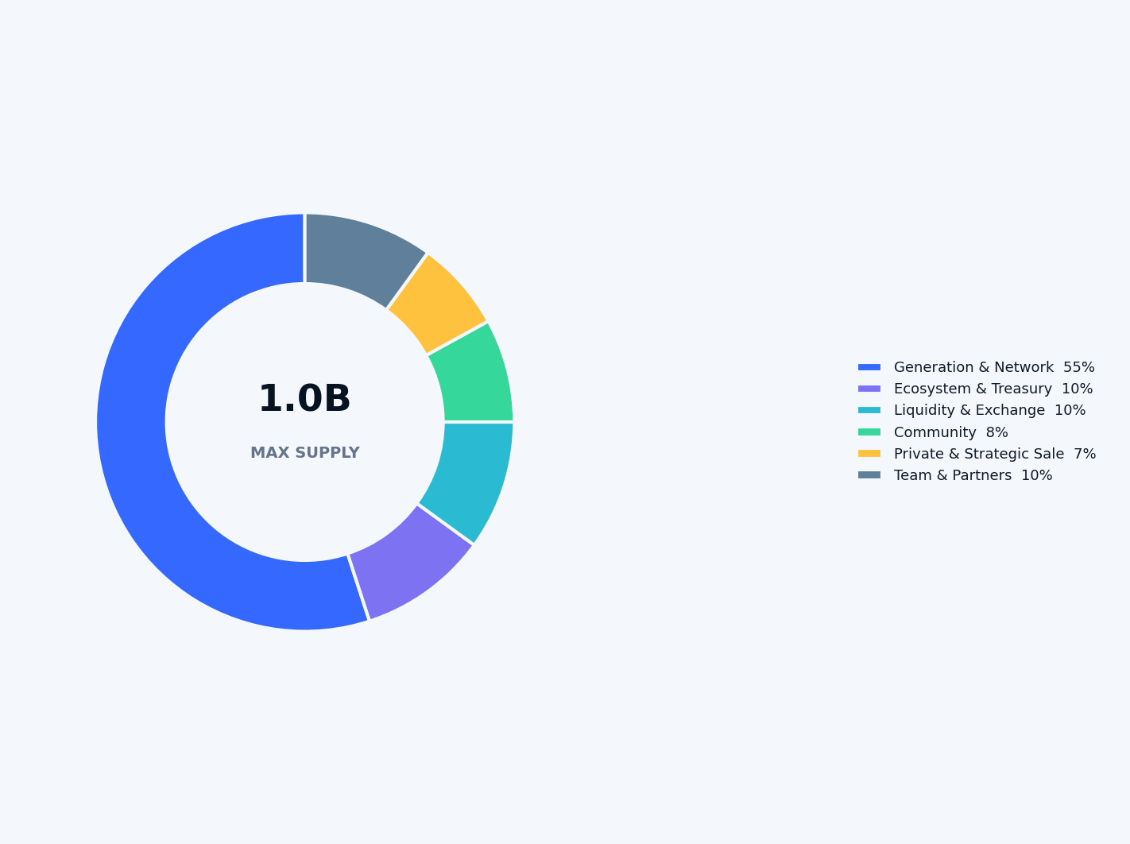
ALLOCATION | SHARE | GIK | PURPOSE
Generation & Network Reserve | 55% | 550,000,000 | Personal generation and eligible network, rank and Village rewards; released only through platform activity.
Ecosystem & Treasury | 10% | 100,000,000 | Platform development, operations, marketing, strategic expansion and long-term ecosystem execution.
Liquidity & Exchange | 10% | 100,000,000 | CEX/DEX liquidity, market-making inventory, exchange integrations and future trading-pair support.
Community | 8% | 80,000,000 | Airdrops, user acquisition, holder-building and community campaigns.
Private & Strategic Sale | 7% | 70,000,000 | Negotiated allocations for strategic investors, key participants and commercial partners.
Team & Partners | 10% | 100,000,000 | Founder, core team, future contributors and strategic partners, subject to long-term vesting.
TOTAL | 100% | 1,000,000,000 | Fixed maximum supply.
10 / TREASURY, RESERVE AND TRANSPARENCY

Treasury, Reserve and Transparency
A strong token economy requires visible allocation, disciplined reserves and verifiable operational controls.

CONTROL | GRID FRAMEWORK
Allocation wallets | Distinct wallets for Generation, Ecosystem & Treasury, Liquidity & Exchange, Community, Private Sale, Team & Partners, and burn.
Reserve coverage | Generation obligations are monitored against available reserve before additional platform capacity is accepted.
Treasury control | Long-term Treasury uses 2-of-3 multisignature approval with independently held signers.
Wallet separation | Treasury, Hot Withdrawal and Sweeper/Gas roles are separated so ordinary automation cannot directly control long-term reserves.
Hot-wallet discipline | The Hot Withdrawal Wallet holds approximately 1–3 days of operating liquidity and uses configurable automatic-signing limits.
Vesting | Material locked allocations are released through on-chain or independently verifiable vesting schedules.
On-chain transparency | Supply, permanent burn, allocation wallets, vesting and material token movements are auditable through BscScan.
Automated settlement | Plant actions, generation, rewards, withdrawals, burn, vesting/unlock and treasury sweeps are automated by default; staff monitor exceptions.
Daily reconciliation | On-chain balances and transactions are reconciled against the append-only internal ledger at least once daily.
Market integrity | No wash trading, undisclosed price support, manipulative liquidity practices or guaranteed market outcomes.

Allocation Release and Vesting Framework
ALLOCATION | INITIAL RELEASE | CLIFF | RELEASE FRAMEWORK
Generation & Network | 0 | None | Activity-linked emission only; no calendar-based release.
Ecosystem & Treasury | 5M GIK | 6 months | Remaining 95M released linearly over 30 months.
Liquidity & Exchange | Up to 20M available | None | Remaining 80M held in a dedicated reserve wallet and deployed only as market infrastructure requires.
Community | 8M GIK | None | Remaining 72M distributed progressively over 24 months.
Private & Strategic Sale | By agreement | By agreement | Written terms vary by size, timing and strategic contribution; deeper discounts require longer lock-up or vesting.
Team & Partners | 0 | 12 months | 100M released linearly over 36 months after the cliff.

Circulating-supply discipline
Allocation does not equal circulation. Only GIK actually emitted, distributed or deployed enters circulation; the 55% Generation Reserve remains activity-linked.

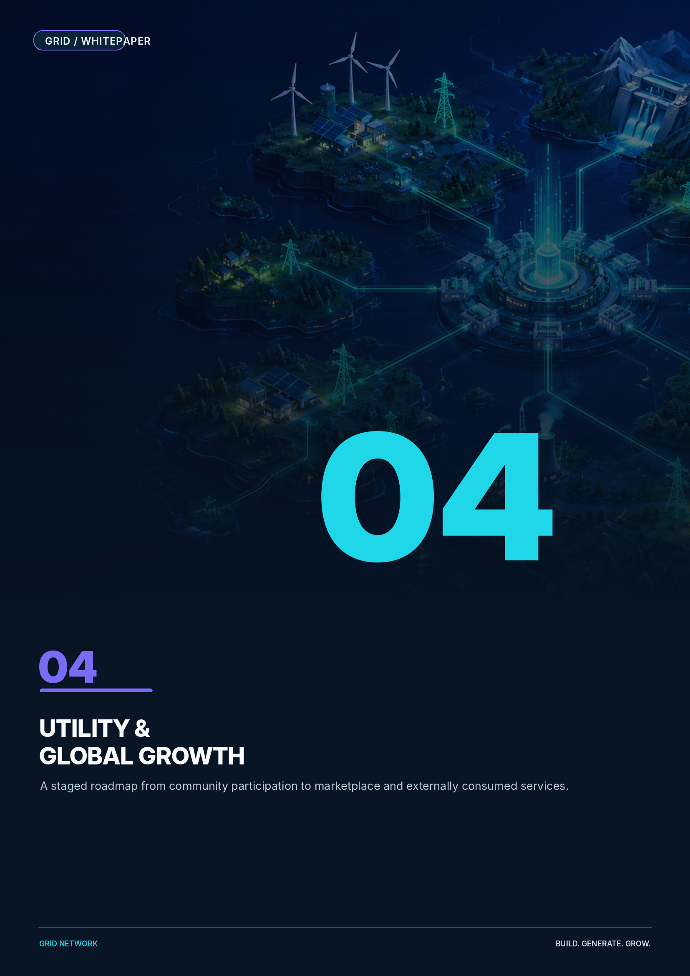
11 / EXTERNAL UTILITY ROADMAP

External Utility Roadmap
GRID is designed to evolve from an internal participation network into a marketplace and externally consumed service economy.

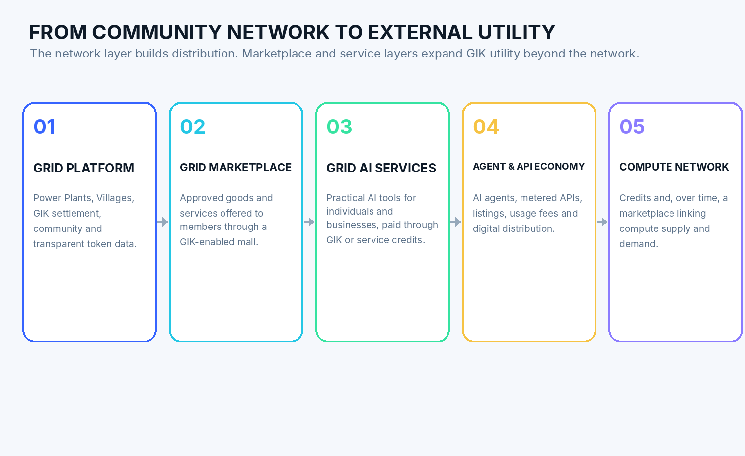

The strategic transition
The network layer creates distribution, community and an initial holder base. The next utility layer enables members to spend GIK on approved goods and services, followed by AI products designed for individuals and businesses that may never participate in the network reward programme.
PHASE | UTILITY | GIK VALUE-CAPTURE DIRECTION
GRID Platform | Virtual Plants, Villages, progression, settlement and token information. | Community participation and recurring platform use.
GRID Marketplace | Approved sellers offer physical goods, digital products and services through a member-oriented mall. | GIK purchase demand, merchant settlement and potential platform fees.
GRID AI Services | AI writing, analysis, automation and business tools. | Service payments in GIK or conversion into service credits.
Agent & API Economy | First- and third-party agents, metered APIs and digital services. | Listing, usage and transaction fees linked to GIK.
Compute Credits | Metered inference and compute consumption. | Fiat or stablecoin payments may be linked to GIK acquisition, conversion or burn.
Compute Network | Long-term connection of compute suppliers and AI users. | Real infrastructure consumption beyond the virtual generation layer.

12 / TECHNOLOGY AND SECURITY

Technology and Security
A fixed-supply token contract is combined with automated Deposit Vaults, GST settlement, role-separated custody, persistent member alerts and daily reconciliation.

COMPONENT | DESIGN DIRECTION
Blockchain | BNB Smart Chain.
Token standard | BEP-20; maximum supply 1,000,000,000 GIK; 18 decimals; additional minting disabled after deployment.
Permanent burn | Transmission Loss uses an irreversible on-chain burn that permanently reduces totalSupply.
Settlement clock | Business settlement occurs daily at 01:00 GST (UTC+9); canonical backend timestamps are stored in UTC.
Reward precision | Reward payouts are floored to whole GIK. Fractional remainders remain unissued.
Deposit Vaults | Each member receives a unique BSC Deposit Vault address rather than sharing a common deposit address.
Deposit automation | A seven-day Deposit Intent supports automatic accumulation, confirmation and Plant action; late or residual GIK becomes Available GIK.
Balance separation | Available GIK, Reward Balance, vesting balances, fees, burns and company balances remain distinct in an append-only double-entry ledger.
Custody roles | Treasury, Hot Withdrawal and Sweeper/Gas roles are separated; Treasury uses 2-of-3 multisig.
Automated withdrawals | Normal low-risk withdrawals may be signed automatically within configurable per-transaction, hourly and daily risk limits.
Reconciliation | On-chain deposits, sweeps, withdrawals, burns and wallet balances are reconciled against the internal ledger at least daily.
Action Center | Persistent banners, modals and an in-platform Action Center keep unresolved member issues visible until resolved.
KYC readiness | The MVP does not impose universal KYC, while retaining account- or action-specific KYC capability where later required.
Contract verification & audit | Source code verification and independent smart-contract audit precede material distribution and exchange integration.
Platform security | Role-based access, immutable logs, anomaly detection, backups, incident response and isolated signing controls.
Automated Personal Deposit Vault flow
External wallet → member-specific BSC Deposit Vault → confirmation listener → automatic Plant action → company-funded Sweeper → central Treasury. Routine processing requires no manual approval.

Why BNB Smart Chain
BSC provides EVM compatibility, common wallet support, broad tooling and relatively low-friction transfers for member-specific Deposit Vaults, automated treasury sweeps and a high-frequency platform economy.

13 / GO-TO-MARKET AND EXCHANGE STRATEGY

Go-to-Market and Exchange Strategy
GRID combines an existing community-distribution capability with a product-first global launch plan.

PRODUCT FIRST  A working public site and gamified member platform provide tangible utility before broad market expansion. | GENUINE COMMUNITY  Official English and Korean channels, real users, real holders and auditable campaigns — not synthetic metrics.
CONTROLLED DISTRIBUTION  Community and private allocations use eligibility controls, vesting and anti-sybil measures as applicable; universal KYC is not assumed for the MVP. | LIQUIDITY DISCIPLINE  GIK/USDT liquidity, transparent circulating supply, defined market-making policy and market-integrity controls.

LAUNCH WORKSTREAM | OBJECTIVE
Community launch | Build a genuine holder base through active Power Plant/Village participation and official channels including X @GRID_network_.
DEX liquidity | Establish transparent GIK/USDT price discovery and on-chain liquidity.
Initial global CEX | Expand access, market depth, visibility and institutional-grade due diligence.
Multi-exchange growth | Add venues as product, holder, volume and liquidity metrics mature.
External AI product launch | Create non-network service consumption and a broader user base.

Market-access principle
Exchange access supports the ecosystem; it is not the product. Long-term value depends on repeated utility, transparent supply and real user demand.

14 / ROADMAP

Roadmap
GRID advances through milestone gates that connect product, token, community and external utility.

MILESTONE | KEY OUTPUT
Foundation | GRID Network project governance, brand system, public communications and version-controlled product specifications.
Token infrastructure | GIK deployment, fixed supply, allocation wallets, vesting, multisig, source verification and audit.
Platform MVP | Operational MVP with multilingual onboarding, member-specific Deposit Vaults, automatic Plant activation, next-day generation, accepted compensation rules, genealogy, Reward/Available balances, withdrawal and permanent burn.
Community activation | Controlled airdrop, genuine holders, X/Telegram growth and initial Village formation.
Market access | DEX liquidity, market-making framework and initial global CEX integration.
GRID Marketplace | Launch a member-oriented mall for approved goods and services purchased with GIK, with seller, settlement and governance rules introduced in stages.
GRID AI Services | Launch the first externally consumed AI product after the core platform and marketplace foundation.
Agent and credit economy | Expand into AI agents, service credits, APIs and usage-linked token consumption.
Compute network | Evaluate and develop a marketplace linking compute supply and AI demand.

15 / ORGANIZATION AND GOVERNANCE

Organization and Governance
GRID is developed under the GRID Network brand with dedicated governance for the platform, token economy, treasury and operating controls.

ITEM | DETAIL
Organization | GRID Network
Project | GRID
Token | GRID Token (GIK)
Founder | Sean Jong
Core mission | Build a transparent, game-like digital power network that expands into marketplace and externally consumed service utility.
Product spaces | Public website, logged-in member world and separate operations console.
Member experience | My Power Plant → My Village → World Grid, with financial and genealogy data connected to the visual world.
Governance principles | Fixed supply, published allocation, multisig treasury, vesting, role-separated custody, daily reconciliation and auditability.
Personal Deposit Address | A unique on-chain BSC Deposit Vault is assigned to each member account.
Operating model | Plant actions, generation, compensation, withdrawals, burn, vesting and sweeps are automated by default; staff handle monitoring and exceptions.
Official X | @GRID_network_

Project vision
Make digital-asset utility understandable, visible and engaging — then connect that community to products people and businesses genuinely consume.

GRID is not designed as a static token campaign. It is designed as an automated platform, a visible community economy and a long-term marketplace and service network connected by GIK.

A / CURRENT PLATFORM PARAMETERS

Current Platform Parameters
A concise summary of the current commercial design. Parameters may be updated through published platform rules and authorised operational configuration.

CATEGORY | CURRENT PARAMETER
Personal generation cap | Up to 200% of recognised active Plant or module capacity.
Plant tiers | 2,000 GIK / 8,000 GIK / 15,000 GIK.
Expansion | 15,000 GIK per independent module after the Core Plant tier.
Referral depth | 5 generations at 2K / 10 generations at 8K / 20 generations at 15K+.
Referral rate | 0.5% of each qualifying downline member’s actual personal generation.
Rank system | R1–R7; differential rates 1%, 2%, 3%, 4.5%, 6%, 8%, 10%.
Center Operations Reward | Differential Center Fee positions of 2.0%, 1.0% and 0.5% floor; maximum aggregate Center Fee is 2.0% of a qualifying sale.
Village Bonus | 0% / 0.5% / 1% / 2% / 3% / 5% / 7%. Each Company Root direct line forms one Village; the entire descendant subtree remains in that Village.
Transmission Loss | 5% / 10% / 20% / 30%. Current active capacity determines the rate; if active capacity is zero, use last active recognised capacity. Burned on-chain.
Compression | None. Ineligible positions still occupy genealogy depth; unpaid amounts are not shifted upward and remain unissued.
Reward Balance | Earned Generation/network rewards; minimum external withdrawal 500 GIK, no member daily withdrawal limit, 24-hour lock after address change.
Reactivation | A new active cycle begins from the newly committed capacity.
Personal Deposit Address | A unique on-chain BSC Deposit Vault is assigned to each member account.
Deposit processing | Seven-day Deposit Intent; underfunded deposits may aggregate. Post-expiry or excess deposits credit Available GIK rather than reviving an expired intent.
Treasury sweep and gas | Company-funded Sweeper consolidates Vault balances; Treasury, Hot Withdrawal and Sweeper/Gas wallet roles are separated.
Operating model | 01:00 GST settlement; next-day Generation; whole-GIK flooring; automated happy path with persistent Action Center and exception handling.

RANK | QUALIFICATION | DIFFERENTIAL RATE
R1 | Total downline sales ≥ 100,000 GIK | 1%
R2 | Total downline sales ≥ 300,000 GIK | 2%
R3 | Total downline sales ≥ 1,000,000 GIK | 3%
R4 | Total downline sales ≥ 3,000,000 GIK | 4.5%
R5 | Sales excluding strongest leg ≥ 5,000,000 GIK | 6%
R6 | Sales excluding strongest leg ≥ 15,000,000 GIK | 8%
R7 | Sales excluding strongest leg ≥ 50,000,000 GIK | 10%

A.1 / MEMBER OPERATIONS

Member Operations
Daily settlement, deposit handling, balances and withdrawal rules are designed for deterministic automation and clear member outcomes.

CATEGORY | CURRENT RULE
GRID Standard Time | GST = UTC+9. Daily settlement occurs at 01:00 GST; backend timestamps remain UTC.
First Generation | No Generation on activation day; eligibility begins at the next 01:00 GST settlement.
Reward precision | Every reward payout is floored to whole GIK; fractional remainders remain unissued.
Deposit Intent | Valid for 7 days. Multiple underfunded deposits may aggregate automatically during the active Intent.
Expiry boundary | Only blockTimestamp < expiresAt is valid. Equality or later is post-expiry and cannot revive the Intent.
Late / excess deposits | Credited in full to Available GIK Balance.
Available GIK use | May fund Plant build, upgrade or expansion with no fee.
Available withdrawal | Minimum 100 GIK; 1% Withdrawal Fee deducted from the request and paid to company Treasury; no burn.
Reward withdrawal | Minimum 500 GIK; no member daily withdrawal maximum; normal low-risk withdrawals are automated.
Address security | New or changed withdrawal address triggers a 24-hour withdrawal lock.
Correction policy | Historical entries remain immutable. Underpayments receive positive corrections; overpayments create Recovery Pending and offset future rewards without a negative Reward Balance.
Member alerts | Toast for transient status; banners/modals for important events; unresolved issues remain in the Action Center.
KYC posture | No universal KYC in the MVP; architecture remains ready for account- or action-specific KYC where later required.
Deterministic member accounting
Available GIK, Reward Balance, fees, burns and Recovery Pending remain separate in the append-only double-entry ledger.

A.2 / GENEALOGY AND CUSTODY CONTROLS

Genealogy and Custody Controls
Literal genealogy, distinct Village and Center structures, role-separated custody and configurable risk limits support transparent operation.

CATEGORY | CURRENT RULE
Village definition | Each direct line beneath the Company Root defines one Village; all descendants remain in that Village regardless of depth.
Center relationship | Center is separate from Village. Multiple independent Center branches and Centers beneath Centers may exist inside one Village.
Center creation | Center status is assigned only when a new Center ID is created; an existing ordinary member is not promoted later.
Center hierarchy | Each independent top-level Center begins at 2.0%; the next Center is 1.0%; deeper Centers use a 0.5% floor; aggregate payout per sale is capped at 2.0%.
Sponsor changes | Prohibited by default. Only a zero-downline ordinary member may be moved by audited administrator exception; Center IDs cannot move.
Genealogy view | Upstream visibility is limited to the direct Sponsor; downline view supports 5 / 10 / 20 / All with pan, zoom, fit and root return.
Member-node fields | Public Member ID, Rank, recognised Plant capacity, current Daily Generation and downline cumulative sales. Personal identity, wallet and reward balances remain hidden.
Custody separation | Treasury, Hot Withdrawal and Sweeper/Gas roles are separated.
Treasury control | 2-of-3 multisignature control with independent signers.
Hot Wallet | Initial target 1,000,000 GIK; replenishment alert at 300,000 GIK; approximately 1–3 days of operating liquidity.
Automatic-signing limits | Initial configurable limits: 50,000 GIK per transaction, 250,000 GIK per hour and 1,000,000 GIK per day.
Gas Wallet | Initial target 0.20 BNB; low-balance alert at 0.05 BNB.
Exception handling | Unauthorised outbound activity pauses the affected flow; liquidity shortages use Pending Liquidity rather than permanent failure.
Reconciliation | On-chain deposits, sweeps, withdrawals, burns and balances are reconciled against the internal ledger at least once daily.
Configurable operating limits
Wallet and signing thresholds are initial risk parameters, not permanent economic rules, and are reviewed as legitimate platform activity scales.

R / REFERENCES AND IMPORTANT NOTICE

References and Important Notice
Selected sources used for market context and protocol design comparison.

SOURCE | TOPIC | URL
[1] International Energy Agency | Energy and AI — Executive Summary | https://www.iea.org/reports/energy-and-ai/executive-summary
[2] OECD | Competition in Artificial Intelligence Infrastructure | https://www.oecd.org/en/publications/competition-in-artificial-intelligence-infrastructure_623d1874-en.html
[3] Filecoin | Decentralised storage network and incentive design | https://filecoin.io/
[4] Helium | Token and Data Credit documentation | https://docs.helium.com/tokens/hnt-token/
[5] Render Network | Burn-Mint Equilibrium | https://know.rendernetwork.com/basics/burn-mint-equilibrium
[6] Akash Network | AKT and compute utility | https://akash.network/token/
[7] BNB Chain | BNB Smart Chain documentation | https://docs.bnbchain.org/bnb-smart-chain/

Important Notice
This whitepaper describes the intended GRID ecosystem and is provided for informational purposes only. It does not constitute investment advice, a prospectus, an offer of securities or a guarantee of token price, liquidity, exchange listing, reward availability or future product delivery. Digital assets are volatile and may lose all value. Platform parameters, token distribution, reward schedules, availability and roadmap items may be updated before launch or through published project rules. Users are responsible for understanding the laws, tax treatment and restrictions applicable in their jurisdiction.
GRID NETWORK • OFFICIAL WHITEPAPER
Build. Generate. Grow.

